Andrew Flanagan
Email: andrewflanagan7@gmail.com Phone/WhatsApp: 880 170 139 4724

Hoani Lambert, cc: Paul James
Deputy Secretary Partnerships & Commissions,
Department of Internal Affairs,
25 July 2026

Complaint: Briget Ridden & DIA’s Public ‘Service’
Drawing your attention to Ridden’s rudeness & lack of elementary Public service of DIA personnel.

In June of last year, I began to “IMPORTANT & URGENT: REALLY appreciate your assistance to (be pointed in the right direction to) get a response from paul goldsmith (office)” emailing DIA senior personnel. I started with 1 DIA person, adding another one to each week’s follow-up email – Ridden was added during this process. By February, 26 DIA personnel were receiving my weekly email – none of them ever responded!

On 9 March, received “This has been forwarded onto relevant unit for action” response from Caroline Greaney of Justice. On 10 March, received first email from Ridden.

Long story short, over the next 3 months Ridden did get a year plus overdue OIA response from goldsmith.

However, zero progress or even mention by Ridden on my major outstanding goldsmith issue I bought to her attention in March. On 16 June, Ridden informed me she could not be of any further assistance – I immediately requested her most appropriate person recommendation/suggestion for me to contact next for assistance. On 17 June, Ridden responded “I cannot offer you any further guidance”!

So, over the next month, I emailed several DPMC personnel – no response.

On 19 July, emailed Ridden:
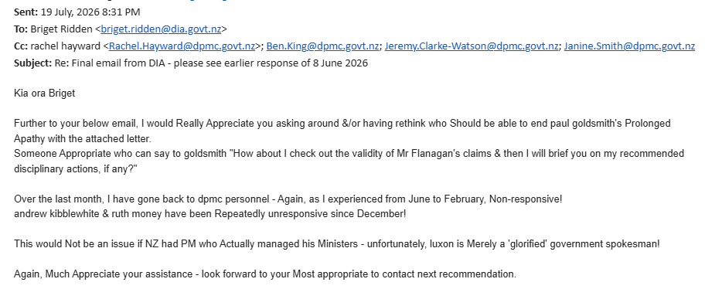

On 22 July, was ‘shocked’ to receive Ridden’s rude response:
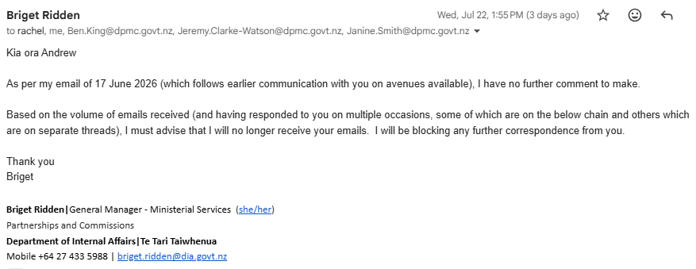

“Ridden:
- If you or any of your 25 colleagues had actually responded during June 2025 to February, that ‘cycle’ would have been shortened!
- ‘Nice’ of supposed Public Servant you to totally ignore my emails for months, yet immediately jump into action on the request of Greaney – really looks like your priority is to try to impress your fellow Government colleagues, while the Public be ‘damned’!
- On reflection, your only interest was resolving the minor outstanding goldsmith issue that ‘fell within your job box’ – the major issue was ‘Not my concern’!
- Even though your knowledge of Government personnel is vastly superior to mine, you could not even be bothered to suggest somebody appropriate for me to contact next about the major issue! Even though you knew I had very frustratingly been trying since February 2025 to progress/resolve that issue, your response was ‘I don’t care, that’s your problem’!”

In summary, I am appalled by the complete lack of very elementary service from the 25 DIA ‘leaders’ & - especially – the rudeness of Ridden!

I strongly recommend you remind your staff they are Public Servants – they are paid to serve the Public! If they do not want to do that, do the Public a favour by resigning.

As an ‘apology’, I look forward to DIA assistance (not from Ridden – do not want to deal with her again) this week with getting goldsmith’s action/response to my enclosed November 2025 letter.

regards
N A Flanagan

